SERVICENOW PROJECT SUBMISSON

# ORDERING A WIFI ROUTER VIA SERVICE NOW SERVICE

**CATALOG**

Submitted by



Y GUNASEKHAR au723921244058

T MAHAMMAD ESMAIL au723921244052

**Arjun College of Technology, Coimbatore**



**Anna University Chennai -600 025**

Project Title: **ORDERING A WIFI ROUTER VIA SERVICNOW SERVICE CATALOG**

# Project Overview:

The objective of this project is to develop an efficient and user-friendly process for ordering Wi-Fi routers through the ServiceNow Service Catalog. This project aims to enhance the experience of end users by streamlining the ordering process, ensuring it is simple, intuitive, and fully integrated into the ServiceNow platform. By using the ServiceNow Service Catalog, the project aims to reduce manual efforts, improve order tracking, and enhance user satisfaction by offering a self-service option that allows users to quickly and easily request Wi-Fi routers as needed. The project will involve creating catalog items, defining approval workflows, and ensuring that users are able to successfully submit requests for Wi-Fi routers, with appropriate tracking and fulfillment procedures in place.

# Objectives:

**Simplify the Wi-Fi Router Ordering Process:**

* Enable users to easily order Wi-Fi routers from the ServiceNow Service Catalog.
* Ensure the catalog item is user-friendly and includes all necessary details for successful order fulfillment.

## Standardize and Automate Approvals:

* + Automate approval workflows to ensure requests are reviewed and processed quickly.
  + Implement role-based approval to ensure appropriate checks are in place for device requests.

## Enhance Visibility and Tracking:

* + Provide real-time updates on the status of Wi-Fi router orders.
  + Implement tracking for requests from submission to fulfillment.

## Improve User Experience:

* + Streamline the catalog item interface to ensure a seamless experience for users requesting routers.
  + Provide a knowledge base to guide users on how to submit requests and track progress.

# Key Features and Concepts Used:

## ServiceNow Service Catalog:

* + Use ServiceNow’s Service Catalog to create a **catalog item** for Wi-Fi router orders.

## Approval Workflows:

* + Implement role-based approval workflows for the router requests.

## Knowledge Base:

* + Create a Knowledge Article to assist users with the ordering process and guide them through any troubleshooting steps.

## Catalog Item Management:

* + Ability to configure and manage catalog items to ensure that the router request process is standardized.

# Detailed Steps to Solution Design:

**IMPLEMENTATION**

## Step: 1

Log in to your ServiceNow instance using the provided credentials.

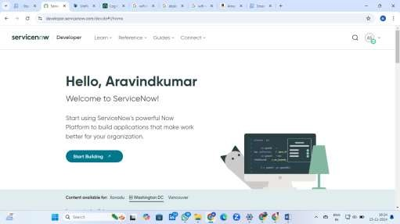

Now you will navigate to the ServiceNow, Pin the **Menu**

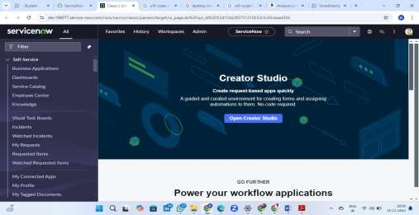

* **Step: 2** Open “Maintain categories” >> **New**, Fill the details as below

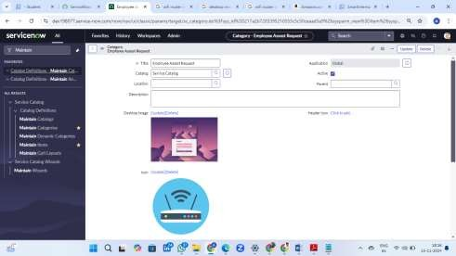

* **Step: 3** Enter a Title for Category
  + Select the Catalog in Which You Are Going to Add
  + Upload the Desktop Image
  + Upload the Icon Image
  + Save

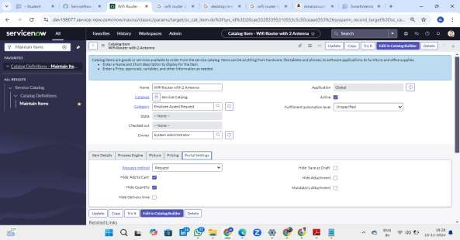

* **Step: 4** Add a New Service Catalog Item in ServiceNow
  + Give a Name for the Catalog Item
  + Select the Catalog
  + Select the Category
  + Save the Item
  + Go to Portal Settings and select the Request
* **Step 5 :** Add variables to the Item

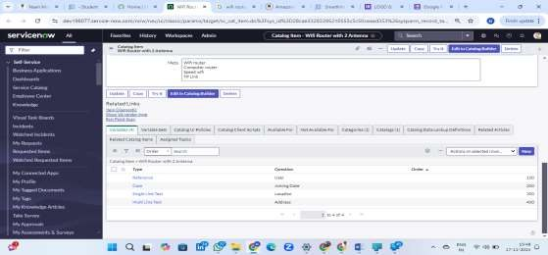

Click on Variables >> New

* **Step 6 :** Add variables to the Item Click on Variables >> New

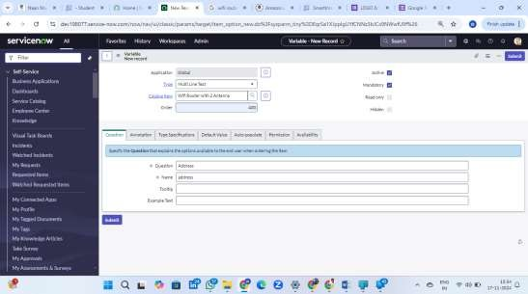

* **Step 7 :** Fill the details as below
* **Step 8 :** Steps to Add Variable for Catalog Item Give a Question for Catalog Item

Name is Autopopulated Save the variable

* **Step 9 :** Open “Portals”

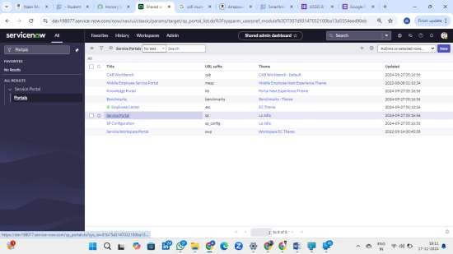

* **Step 10 :** Select Service Portal Select Catalogs

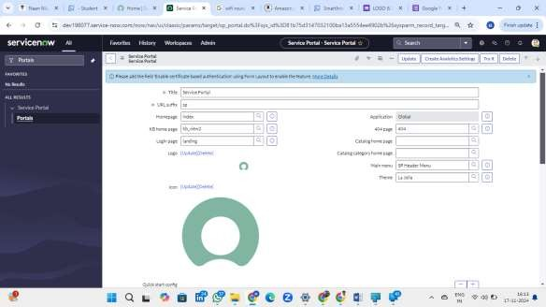

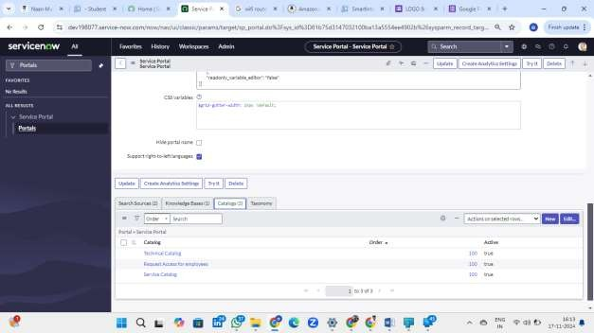

* **Step 11 :** Select Edit

Select the Category and Add to Service Portal and Save

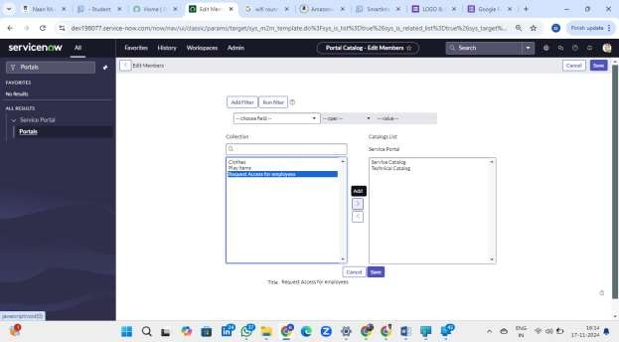

* **Step 12 :** Search for Workflow Editor

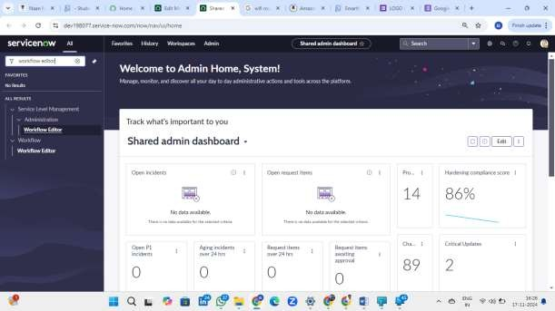

* **Step 13 :** Open Workflow Editor >> New Workflow

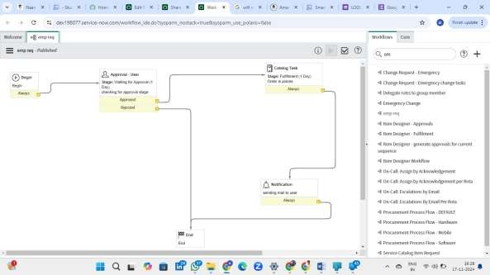

**Create a workflow for process Automation**

Step-by-Step Implementation :

1. Item Request by User:
   * A user submits a request for an item through a form or a specific request interface.
2. Approval Workflow:
   * The request goes into a pending state, awaiting approval from an authorized user or admin.
   * Notifications can be sent to potential approvers to review the request.
3. Catalog Task Creation:
   * Upon approval, a task is created in the catalog or inventory system to process the request.
   * This task involves verifying item availability, preparing the item for delivery, etc.
4. Email Notification:
   * Once the catalog task is completed and the order is successfully placed, an email is sent to the user notifying them of the successful placement of their order.

**Step 14:** Add the workflow to the item

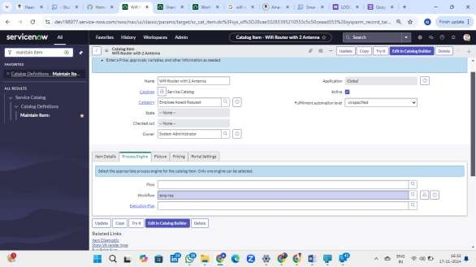

**Step 15:** Open Service Portal and make a Request for item

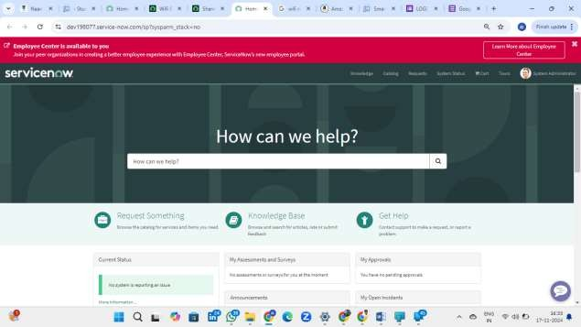

Enter additional variables (such as quantity, preferred delivery date, and comments) below the item field in a request form and then submit the request.

**Step 16:** Placing Request

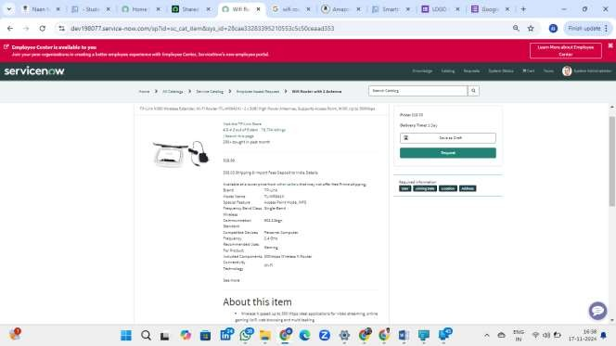

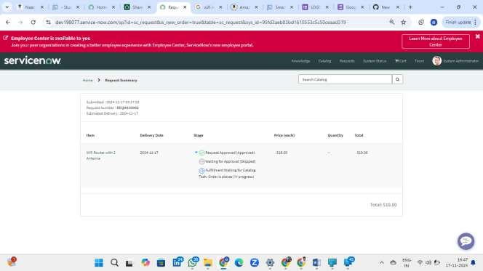

**Step 17:** Open “My Requests”

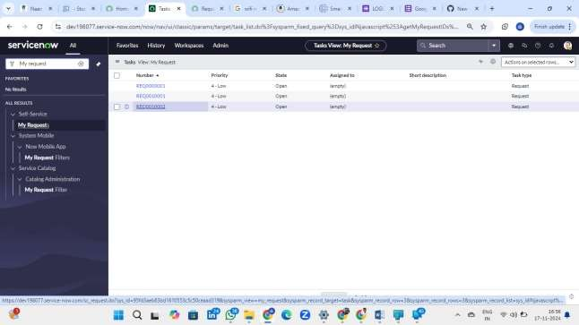

**Step 18:** Open Request Record

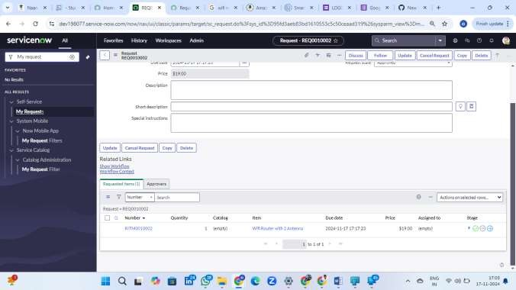

**Step 19:** Open Request item

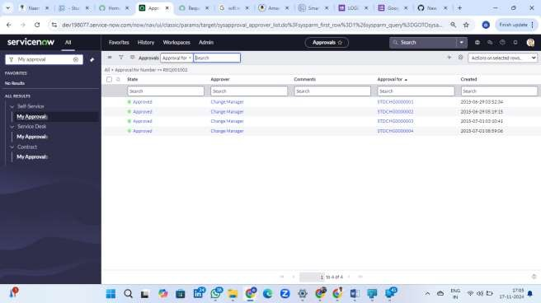

**Step 20:** waiting for approval Then task is created

**Step 21:** Open the Service Catalog Task

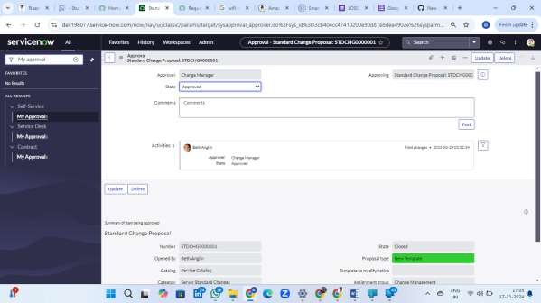

Click on Close task

**Result**

Email Notification will be sent

**Step 1 :** Open “Emails”

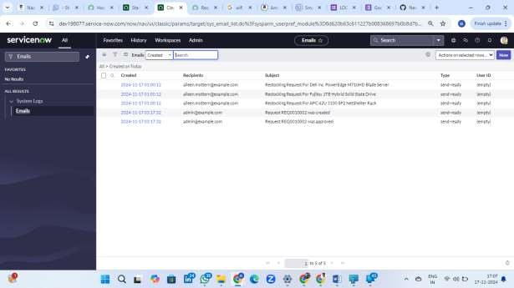

**Step 2 :** Check the Email

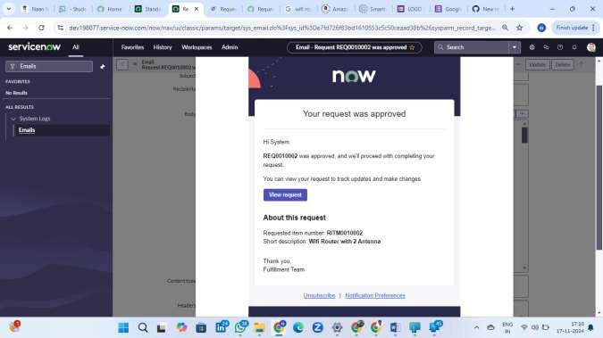

Request was Approved and Order is placed successfully

# Result:

## Wi-Fi Router Order Request Process:

* + - A fully functional Wi-Fi router order request system through the ServiceNow Service Catalog.
    - Users can easily request a Wi-Fi router by selecting the item from the catalog, submitting necessary information, and awaiting approval.

## Approval Process:

* + - The approval workflow ensures that all router orders are reviewed and approved by designated personnel before being processed.

## Knowledge Management:

* + - Users have access to a detailed knowledge article that guides them through the ordering process and answers common questions.

**OVERVEW OF PROJECT:**

**Create Catalog Item for Wi-Fi Router Order**

1. Navigate to the ServiceNow platform.
2. Go to *Service Catalog > Catalog Definitions > Maintain Items*.
3. Click on *New* to create a new catalog item.
4. Fill in the required fields:
   * **Name:** Wi-Fi Router Order
   * **Description:** Request a Wi-Fi router for personal or office use.
   * **Category:** Hardware
   * **Price:** ($19)
   * **Short Description:** Request a Wi-Fi router.
5. In the *Available For* section, select the appropriate user roles or groups that will have access to this catalog item.
6. **Save** the catalog item.

## Activity 2: Configure Approval Workflow

1. Go to *Workflow > Workflow Editor*.
2. Create a new workflow for the Wi-Fi router catalog item.
3. Define the approval process, such as routing requests to a specific manager or IT team for review.
4. Configure email notifications to notify the requester when the order has been approved or rejected.
5. Publish the workflow.

## Activity 3: Define Knowledge Article for Wi-Fi Router Ordering Process

1. Navigate to *Knowledge Management > Knowledge Articles*.
2. Create a new knowledge article with instructions on how to order a Wi-Fi router through the Service Catalog.
3. Include details on:
   * The types of Wi-Fi routers available.
   * Instructions on how to select the correct model.
   * How to submit a request.
   * Estimated fulfillment time.
4. Link the knowledge article to the Wi-Fi router catalog item for easy access.

## Activity 4: Testing the Catalog Item and Workflow

1. Test the Wi-Fi router ordering process by submitting a request as a user.
2. Verify that the approval workflow is triggered and that the request is properly routed to the right approvers.
3. Ensure that the catalog item is displayed correctly in the Service Catalog and that the user is able to submit requests easily.
4. Check if the Knowledge Article is linked and accessible to the user.

## Activity 5: Monitor and Validate Fulfillment

1. Track the order status through the *Requests* and *Tasks* modules in ServiceNow.
2. Verify that the approval process is functioning as expected and that the order is fulfilled within the expected timeframe.
3. Gather feedback from users on the ease of use of the ordering system.

# Testing and Validation:

## Catalog Item Testing:

* + - Verified that users can successfully submit Wi-Fi router requests from the Service Catalog.
    - Checked that the catalog item displays correctly and that users are guided with appropriate details.

## Approval Workflow Testing:

* + - Validated that the approval workflow is triggered and notifications are sent to both the requester and the approver.

## Knowledge Article Validation:

* + - Ensured that the Knowledge Article provides accurate, helpful, and clear instructions on how to place a router request.

# Key Scenarios Addressed by ServiceNow in the Implementation Project:

## Wi-Fi Router Ordering and Tracking:

* + - Scenario: Users need to order a Wi-Fi router and track the progress of their request. ServiceNow provides an integrated system to manage requests, approvals, and order fulfillment.

## Approval Workflow Automation:

* + - Scenario: Router requests require approval from designated personnel before processing. ServiceNow automates the approval process to ensure that requests are reviewed and authorized efficiently.
  + **Self-Service Capability:** Scenario: End users want to place router orders without relying on IT support. The ServiceNow Service Catalog provides a self-service interface where users can place requests directly, improving efficiency and reducing the workload on IT teams.

# Conclusion:

The implementation of an ordered Wi-Fi router request process via the ServiceNow Service Catalog provides a streamlined and efficient method for users to request hardware items, such as Wi-Fi routers, while ensuring that the approval and fulfillment processes are automated and tracked. By utilizing ServiceNow's powerful catalog management, workflow automation, and knowledge management features, organizations can provide a seamless self-service experience for users, reduce manual intervention, and enhance operational efficiency.

This project not only simplifies the ordering process for Wi-Fi routers but also contributes to a more efficient and organized workflow, improving both user satisfaction and IT operational performance. Ultimately, by leveraging ServiceNow's capabilities, organizations can enhance their service delivery and ensure better management of hardware requests within the IT service ecosystem.